**Experiment-3 Study of Static Routing**

**Aim:** Understanding and implementing static routing for simulating package transfer between different networks.

**Tools Used:** Cisco Packet Tracer

**Theory:**

Static routing is a network routing technique where routes are manually configured and maintained by network administrators. In this method, fixed paths between network devices are established, ensuring that data packets always follow the same route, regardless of network changes or conditions.

### **Key Characteristics of Static Routing**

1. **Manual Configuration:** Routes are manually added to the routing table of each device. This process requires a thorough understanding of the network's layout and careful planning to ensure accurate and efficient routing.
2. **Predictability:** Because the routes are predefined, static routing offers a predictable path for network traffic, making it advantageous in stable networks with consistent traffic flows.
3. **Simplicity:** Static routing is easy to implement and manage in small networks with a few routes. It does not require complex protocols or algorithms for route calculation.
4. **Low Overhead:** Unlike dynamic routing, static routing does not generate additional network traffic for maintaining routing information, which reduces overhead.
5. **Control:** Administrators have full control over the routing paths, enabling customized routing policies and potentially enhancing security.

### **Advantages of Static Routing**

* **Low Resource Use:** Static routes do not need CPU or memory resources to calculate routes, making them ideal for devices with limited resources.
* **Security:** Since routes are manually configured, the risk of incorrect routing information spreading through the network is minimized, which can be a concern with dynamic routing protocols.
* **Stability:** Static routing is less prone to routing loops and network topology changes.

### **Disadvantages of Static Routing**

* **Limited Scalability:** Managing static routes in large networks can be cumbersome and error-prone, as any change in the network requires manual updates.
* **Inflexibility:** Static routes do not adapt to changes or failures in the network, leading to potential suboptimal routing or communication failures if a link goes down.
* **Complexity in Large Networks:** As networks grow, managing static routes becomes increasingly complex, making it less practical for larger or more dynamic environments.

### **Applications of Static Routing**

Static routing is typically used in small networks, specific routes within larger networks, or scenarios where the network topology is stable. It is also useful for default routes, backup routes, or routing traffic through a specific path for security or policy reasons.

**Procedure:**

1. Open Cisco Packet Tracer application on computer.
2. Use PCs and give them IP addresses to the PCs and then configure the routes to the Router and make each and every possible combination to get all the routes available to send and get acknowledgement of data.
3. Use PT Switch and Router only as they’re already defined according to our use.
4. Use RJ45 Cables to connect the PCs and switches as according to the topology diagram. We can check the connections using ping in the command prompt of each PC.
5. Try sending mail from one PC to another and start simulation and observe.
6. Try Sending on different paths like 1st router sub-PC to 2nd router sub-PC etc..

**Possible IPs in each Router:**

**Router 1**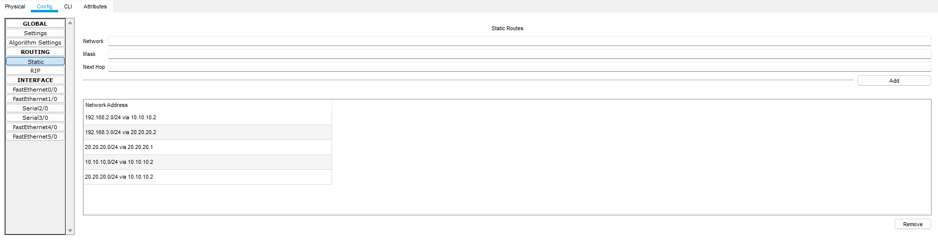

**Router 2**



**Router 3**



**Connections:**

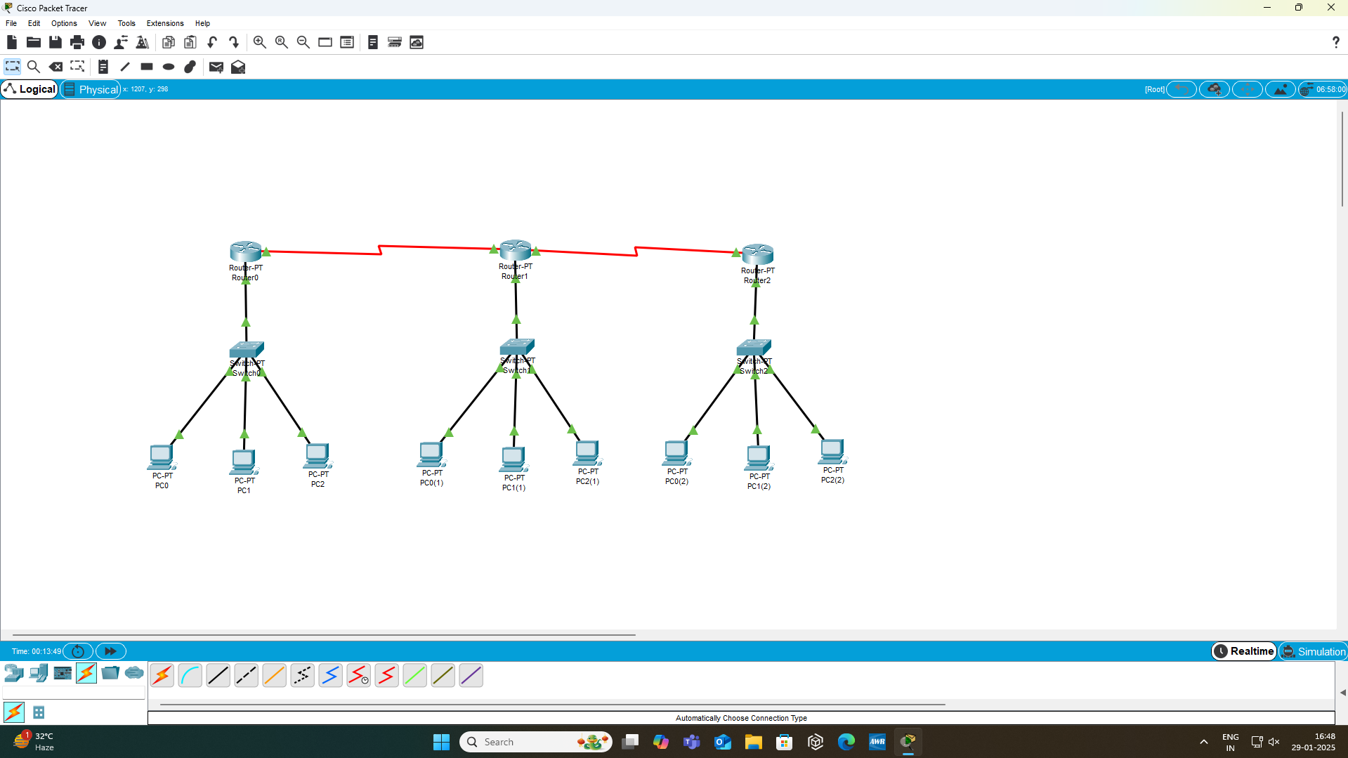

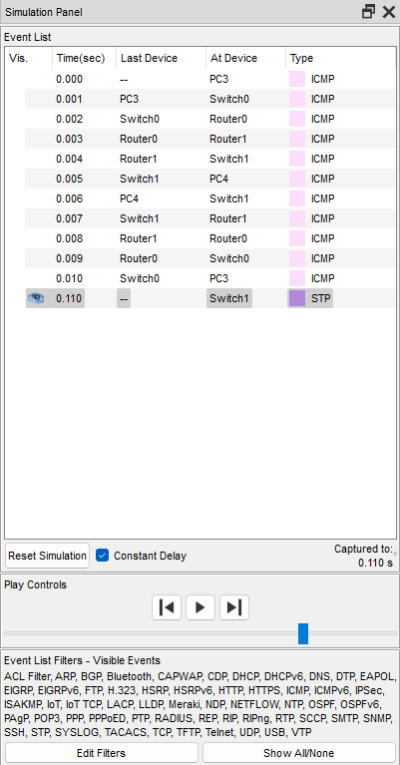**Testing on Routes:**

**R1-R2 R2-R3 R1-R3**

**Success:**







**Result:**

In this analysis, we’ve tried the static routing for 3 routers and their sets of PCs and made sure that each PC has a connection with every other PCs via router (i.e. routing).

**Conclusion:**

Here are some points from which we found about the static routing:

1. **Straightforward Approach**: Static routing offers a simple and controlled method of network routing.
2. **Beneficial for Small, Stable Networks**: It is particularly advantageous for small networks with consistent traffic patterns.
3. **Predictability**: Provides predictable routing paths due to predefined routes.
4. **Simplicity and Low Overhead**: Easy to implement and manage without complex protocols, reducing overhead.
5. **Manual Configuration Required**: Requires thorough understanding and careful planning of the network layout.
6. **Specific Applications**: Best suited for scenarios where network topology remains static, such as default routes, backup routes, or routing traffic through specific paths for security or policy reasons.